Assignment: Build a Simple Company Website Using ASP.NET MVC and Bootstrap
Objective
Create an ASP.NET MVC application that demonstrates multiple controllers and views, all integrated using a shared _Layout.cshtml page with Bootstrap navigation.
The focus is on UI structure and MVC routing, not backend logic.

Step 1 – Create MVC Project
Create a project:
ASP.NET Core Web App (Model-View-Controller)
Project name:
CompanyPortal
Run the project once to verify it works.

Step 2 – Create Controllers
Create the following controllers.
1. HomeController
Controllers/HomeController.cs
public class HomeController : Controller
{
public IActionResult Index()
{
return View();
}
public IActionResult About()
{
return View();
}
}

2. ServicesController
public class ServicesController : Controller
{
public IActionResult Index()
{
return View();
}
public IActionResult Consulting()
{
return View();
}
public IActionResult Training()
{
return View();
}
}

3. ProductsController
public class ProductsController : Controller
{
public IActionResult Index()
{
return View();
}
public IActionResult Software()
{
return View();
}
public IActionResult Tools()
{
return View();
}
}

4. ContactController
public class ContactController : Controller
{
public IActionResult Index()
{
return View();
}
}

Step 3 – Create Views
Create corresponding views.
Example:
Views/Home/Index.cshtml
Views/Home/About.cshtml
Views/Services/Index.cshtml
Views/Services/Consulting.cshtml
Views/Services/Training.cshtml
Views/Products/Index.cshtml
Views/Products/Software.cshtml
Views/Products/Tools.cshtml
Views/Contact/Index.cshtml
Each page should contain Bootstrap components.

Step 4 – Modify _Layout.cshtml
Add a Bootstrap Navbar.
Views/Shared/_Layout.cshtml

Use Dropdown menus for each controller, for sample-
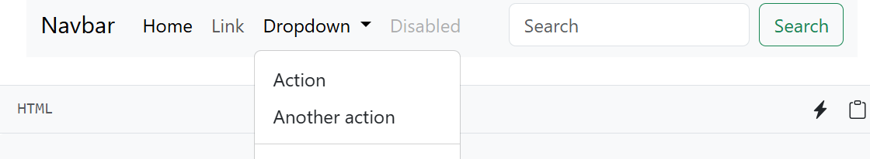

Step 5 – Use Bootstrap Components in Pages
Students must use different Bootstrap components in each page.
Home Page
Use:
- Jumbotron / Hero section
- Cards
Example components:
Bootstrap Card
Bootstrap Button

About Page
Use:
Bootstrap Alert
Bootstrap List Group

Services Pages
Use:
Bootstrap Accordion
Bootstrap Cards

Products Pages
Use:
Bootstrap Table
Bootstrap Badges

Contact Page
Use:
Bootstrap Form
Bootstrap Input fields
Bootstrap Button
(No form submission logic required.)

Step 6 – Routing Verification
Students must test these URLs:
/Home/Index
/Home/About
/Services/Consulting
/Services/Training
/Products/Software
/Products/Tools
/Contact
And verify navigation via the layout menu.

Expected Output
Application should contain:
- 4 controllers
- 8+ views
- Shared layout
- Bootstrap navbar
- Dropdown menus
- Bootstrap UI components

Learning Outcomes
Students will understand:
- MVC project structure
- Controllers and actions
- Razor Views
- Shared layout (_Layout.cshtml)
- Navigation with asp-controller and asp-action
- Bootstrap UI integration
- View routing

